PP Fusion

Plastic Short Body Bib Cock – Wall Mounted (Blue & White)

**Product Description:**  
This wall-mounted plastic short body bib cock is a lightweight and economical water control solution ideal for household, garden, and utility areas. Made from high-quality virgin plastic, it ensures smooth operation, easy installation, and long-term durability with a colorful, stylish look.

**Key Features:**

1. Made from virgin polypropylene for long life
2. Ergonomic handle for smooth quarter-turn operation
3. Rust-free and corrosion-resistant body
4. Ideal for indoor and outdoor utility areas
5. Lightweight and easy to install on standard connections

**Product Specifications:**

* **Material:** Virgin Polypropylene Plastic
* **Color:** Blue Handle & Wall Flange with White Body
* **Mount Type:** Wall Mounted
* **Size:** ½ inch BSP thread (standard)
* **Handle Type:** Quarter-turn lever handle
* **Usage:** Bathrooms, gardens, utility sinks, washing areas
* **Installation:** Tool-free manual installation
* **Flow Control:** Manual on/off
* **Finish Type:** Glossy surface finish
* **Maintenance:** Easy to clean, low-maintenance design

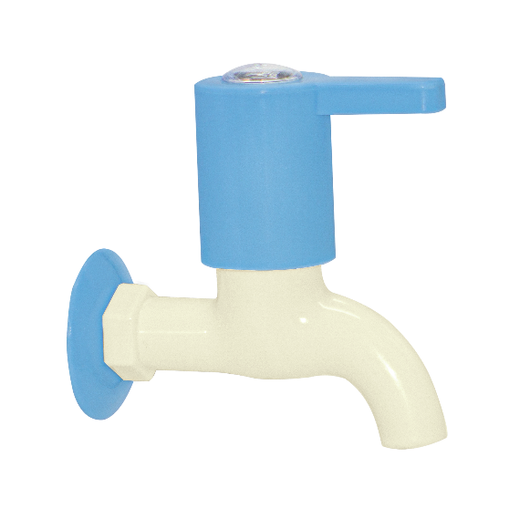

Plastic Long Body Bib Cock – Wall Mounted (Blue & White)

**Product Description:**  
The Plastic Long Body Bib Cock is a lightweight, corrosion-resistant water tap designed for wall-mounted installation in bathrooms, wash areas, and outdoor spaces. With its extended outlet, it offers greater reach and convenience, and its high-quality plastic construction ensures durability and smooth performance.

**Key Features:**

1. Long body design provides extended reach for better usability
2. Made from virgin polypropylene for strength and longevity
3. Smooth quarter-turn lever handle for easy operation
4. Rust-free and maintenance-friendly construction
5. Ideal for indoor and outdoor applications

**Product Specifications:**

* **Material:** Virgin Polypropylene Plastic
* **Color:** Blue Handle & Flange with White Body
* **Mount Type:** Wall Mounted
* **Size:** ½ inch BSP thread
* **Handle Type:** Single Lever (Quarter Turn)
* **Body Type:** Long Body for extended reach
* **Application:** Bathrooms, balconies, utility areas, gardens
* **Installation:** Threaded connection with wall flange
* **Finish:** Glossy and smooth surface
* **Durability:** High resistance to chemicals and weathering

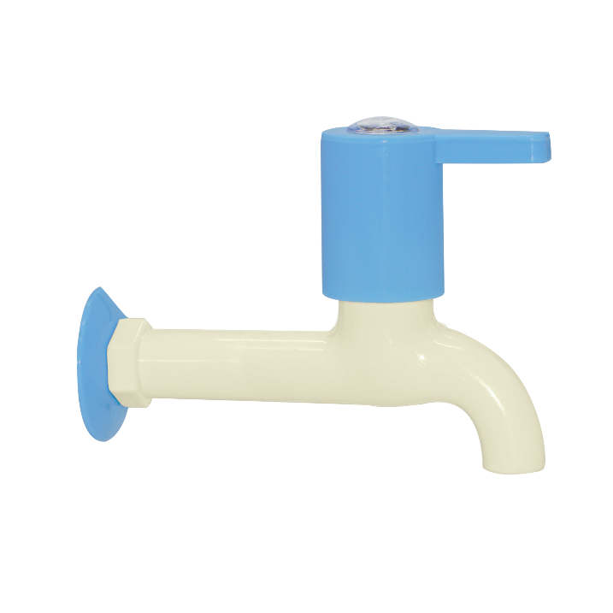

Plastic Bib Cock with Nozzle – Wall Mounted (Blue & White)

**Product Description:**  
This wall-mounted plastic bib cock with nozzle is a multi-functional water tap designed for use with garden hoses, washing machines, and utility sinks. Constructed from virgin polypropylene, it offers a rust-proof, lightweight, and durable solution for household and outdoor water supply needs, featuring a nozzle for easy hose attachment.

**Key Features:**

1. Integrated nozzle for direct hose connection
2. Made from high-quality virgin plastic for durability
3. Smooth lever handle ensures effortless flow control
4. Rust and chemical resistant – ideal for outdoor use
5. Quick and easy wall-mounted installation

**Product Specifications:**

* **Material:** Virgin Polypropylene Plastic
* **Color:** Blue Handle & Flange, White Body and Nozzle
* **Mount Type:** Wall Mounted
* **Size:** ½ inch BSP inlet thread
* **Handle Type:** Single Lever (Quarter Turn)
* **Outlet Type:** Hose nozzle with threaded locking
* **Application:** Garden hoses, washing areas, laundry, utility sinks
* **Finish:** Smooth, glossy surface
* **Temperature Resistance:** Up to 60°C
* **Installation:** Manual thread fitting with included wall flange

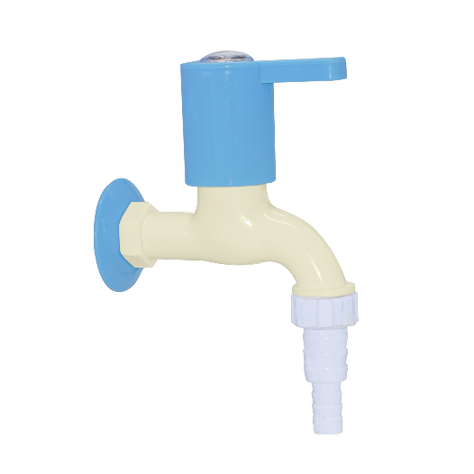

Plastic Swan Neck Tap – Pillar Mounted (Blue & White)

**Product Description:**  
The Plastic Swan Neck Tap is a stylish, pillar-mounted faucet ideal for kitchen sinks and washbasins. Made from virgin polypropylene, this tap features a high-arching spout for extended reach and splash-free use. Its lightweight, rustproof body and smooth operation make it perfect for domestic and utility applications.

**Key Features:**

1. Elegant swan neck design for wide sink coverage
2. Made from durable, virgin-grade polypropylene
3. Smooth quarter-turn lever handle for easy control
4. Rust and corrosion-resistant for long-term use
5. Quick and secure pillar-mount installation

**Product Specifications:**

* **Material:** Virgin Polypropylene Plastic
* **Color:** Blue Handle, White Body and Spout
* **Mount Type:** Pillar Mounted (deck installation)
* **Size:** ½ inch BSP inlet thread
* **Spout Type:** Fixed Swan Neck
* **Handle Type:** Single Lever (Quarter Turn)
* **Usage:** Kitchen sinks, washbasins, utility counters
* **Installation Hole Size:** Standard basin hole (≈25 mm)
* **Finish:** Glossy surface finish
* **Temperature Resistance:** Up to 60°C
* **Includes:** Rubber washer and fixing nut

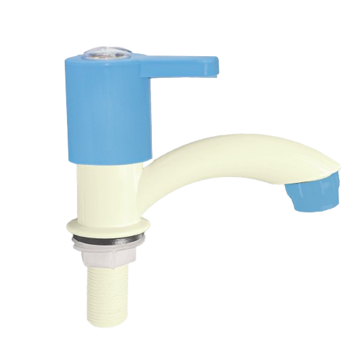

Plastic 2-in-1 Angle Bib Cock with Nozzle – Wall Mounted (Blue & White)

**Product Description:**  
This Plastic 2-in-1 Angle Bib Cock with integrated nozzle is a versatile, wall-mounted water control solution designed for multipurpose use. Crafted from durable virgin polypropylene, it features dual outlets controlled by separate levers—ideal for connecting both a garden hose and a washing machine simultaneously while maintaining a sleek, modern look.

**Key Features:**

1. Dual outlets for simultaneous water access
2. Made from virgin polypropylene for rust-free durability
3. One outlet includes a nozzle for hose or appliance attachment
4. Smooth quarter-turn lever handles for easy operation
5. Wall flange included for clean installation

**Product Specifications:**

* **Material:** Virgin Polypropylene Plastic
* **Color:** Blue Handle & Flange with White Body
* **Mount Type:** Wall Mounted
* **Size:** ½ inch BSP inlet thread
* **Outlets:** 2 (Main spout + Hose nozzle)
* **Handles:** Dual quarter-turn levers
* **Applications:** Bathrooms, utility areas, washing machine, garden hoses
* **Finish:** Glossy surface, easy to clean
* **Temperature Resistance:** Up to 60°C
* **Includes:** Wall flange, integrated nozzle connector

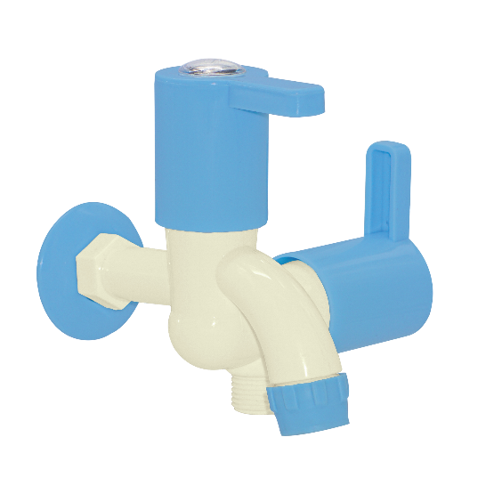

Plastic 2-Way Angle Valve Bib Cock – Wall Mounted (Blue & White)

**Product Description:**  
This Plastic 2-Way Angle Valve Bib Cock is a multipurpose, wall-mounted water outlet solution ideal for bathrooms, washing machines, and utility areas. It features two independently operated levers and outlets, allowing control of two water channels from a single inlet. Made from durable virgin plastic, it is rustproof and leak-resistant for long-term use.

**Key Features:**

1. Dual outlet control with separate quarter-turn levers
2. Virgin polypropylene body ensures corrosion-free durability
3. Compatible with washing machines, jet sprays, and garden hoses
4. Space-saving design ideal for utility corners
5. Wall flange included for secure and aesthetic installation

**Product Specifications:**

* **Material:** Virgin Polypropylene Plastic
* **Color:** Blue Handles & Flange, White Body
* **Mount Type:** Wall Mounted
* **Inlet Size:** ½ inch BSP thread
* **Outlet Type:** Two outlets (Jet spray + tap)
* **Control Mechanism:** Dual independent levers (quarter turn)
* **Applications:** Bathrooms, laundry, jet sprays, dual plumbing points
* **Finish:** Glossy, easy-to-clean surface
* **Temperature Resistance:** Up to 60°C
* **Includes:** Wall flange and rubber washer

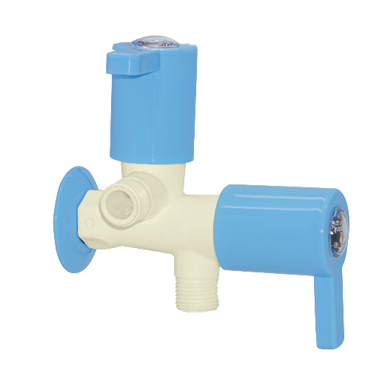

Plastic Sink Cock Tap – Wall Mounted (Blue & Ivory Finish)

**Product Description:**  
This wall-mounted Plastic Sink Cock Tap is crafted from high-quality virgin polypropylene and features a stylish blue and ivory dual-tone design. Ideal for kitchen sinks or utility areas, its high-arc spout offers optimal clearance for washing and filling large utensils. The ergonomic single lever handle ensures smooth water control and long-term performance.

**Key Features:**

1. High-arc spout for better reach and convenience
2. Single lever control for easy flow regulation
3. Rust-proof and corrosion-resistant virgin plastic
4. Stylish dual-tone finish enhances decor appeal
5. Wall-mounted design saves counter space

**Product Specifications:**

* **Material:** Virgin Polypropylene Plastic
* **Color:** Ivory Body with Blue Handle & Flange
* **Mount Type:** Wall Mounted
* **Spout Type:** Swivel High-Arc Spout
* **Control Type:** Single Lever, Quarter Turn
* **Inlet Size:** ½ inch BSP threaded connection
* **Temperature Resistance:** Up to 60°C
* **Finish:** Glossy, easy-to-clean surface
* **Ideal Use:** Kitchen sinks, utility basins, service areas
* **Includes:** Flange and rubber washer

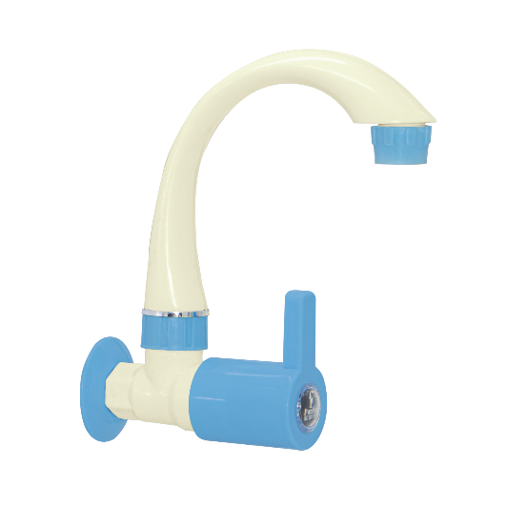

Plastic Angular Stop Cock – Wall Mounted (Blue & Ivory)

**Product Description:**  
This wall-mounted plastic angular stop cock is ideal for regulating water flow to connected appliances or fixtures. With its compact 90-degree outlet design and easy quarter-turn operation, it provides precise control and durable performance. The dual-tone finish adds a modern touch to any bathroom or kitchen setup.

**Key Features (Single Line):**

1. 90-degree angular design for directional water control
2. Single lever quarter-turn operation for ease of use
3. Durable virgin polypropylene body resists corrosion
4. Attractive dual-tone finish enhances aesthetics
5. Compact design ideal for confined plumbing spaces

**Product Specifications:**

* **Material:** Virgin Polypropylene Plastic
* **Color:** Ivory Body with Blue Handle & Flange
* **Mount Type:** Wall Mounted
* **Outlet Type:** Male Threaded Angular Outlet (½ inch BSP)
* **Inlet Size:** ½ inch BSP
* **Control Type:** Quarter Turn Lever
* **Finish:** Glossy, easy to clean
* **Application:** Suitable for geysers, cisterns, and washing machines
* **Includes:** Wall flange and rubber washer

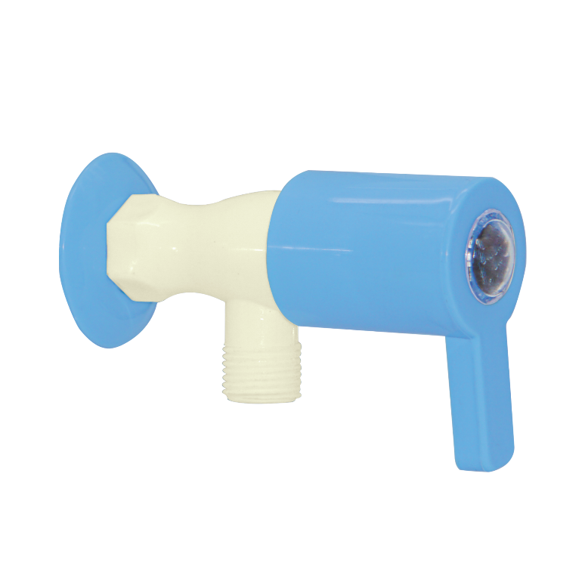

Plastic Short Body Bib Tap – Wall Mounted (Blue & Ivory)

**Product Description:**  
A compact and durable bib tap designed for wall mounting, this model is ideal for home and garden use. Its short body construction allows easy operation and effective water flow, while the attractive blue and ivory color scheme enhances the tap’s modern aesthetic.

**Key Features (Single Line):**

1. Short body design for space-saving wall installation
2. Quarter-turn lever for smooth water control
3. Made from strong, rust-free virgin polypropylene
4. Elegant blue handle with ergonomic grip
5. Ribbed nozzle for secure hose attachment

**Product Specifications:**

* **Material:** Virgin Polypropylene Plastic
* **Color:** Ivory Body with Blue Handle and Nozzle
* **Mount Type:** Wall Mounted
* **Inlet Size:** ½ inch BSP (British Standard Pipe)
* **Outlet Type:** Ribbed spout (suitable for hose fitting)
* **Operation:** Single Lever, Quarter Turn
* **Finish:** Glossy surface, easy to clean
* **Application:** Suitable for domestic use, gardens, and washing areas
* **Includes:** Wall flange and washer

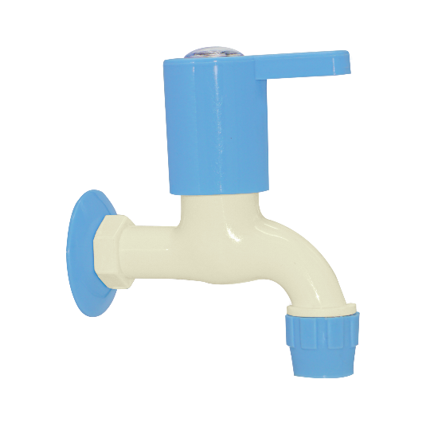

Plastic Swan Neck Sink Tap – Table Mounted (Blue & Ivory)

**Product Description:**  
A stylish and functional plastic swan neck sink tap with a table-mounted design, ideal for kitchen and basin use. Its long, arched neck offers convenience and extended reach, while the modern color scheme complements contemporary interiors.

**Key Features (Single Line):**

1. Swan neck design for high reach and better clearance
2. Table-mounted base for easy countertop installation
3. Made from durable, rust-proof polypropylene plastic
4. Smooth quarter-turn lever handle for effortless control
5. Elegant blue and ivory finish with threaded spout for accessories

**Product Specifications:**

* **Material:** Virgin Polypropylene Plastic
* **Color:** Ivory Body with Blue Handle and Mount
* **Mount Type:** Table Mounted (Deck Mount)
* **Spout Type:** Swan Neck with Threaded Tip
* **Inlet Size:** ½ inch BSP (British Standard Pipe)
* **Handle Type:** Single Lever, Quarter Turn
* **Finish:** Glossy, Easy-to-Clean Surface
* **Application:** Suitable for kitchen sinks and wash basins
* **Accessories Included:** Rubber washer and plastic lock nut

